Central Selkirk Caribou Maternity Penning Protocols and Guidelines

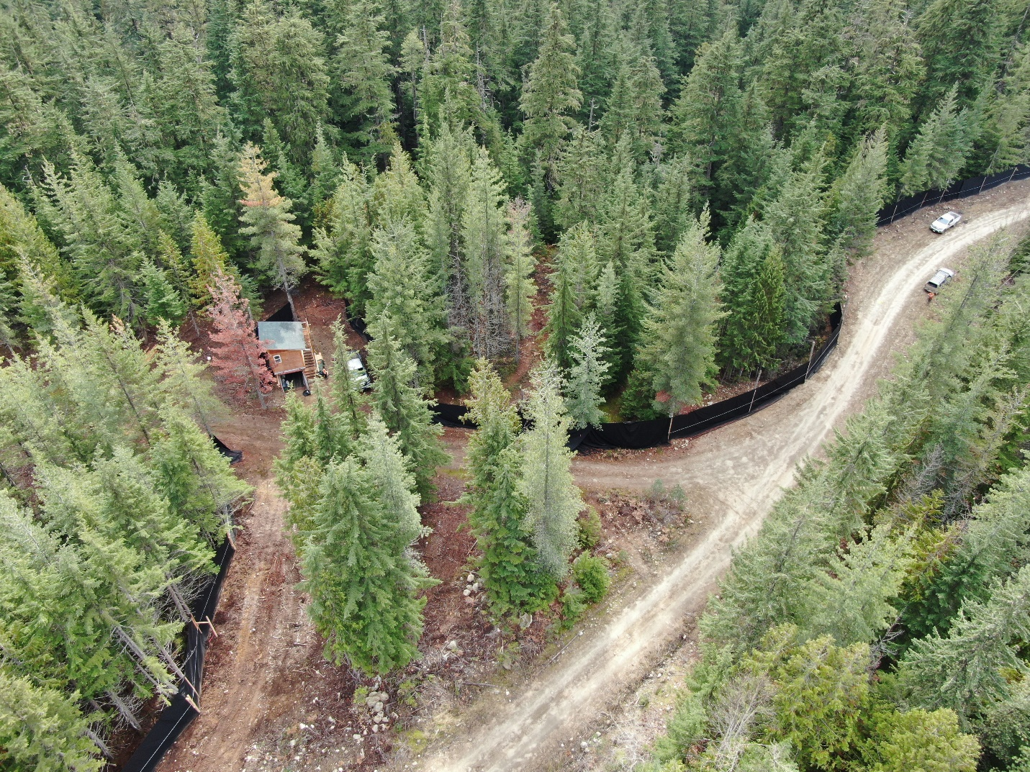

Arrow Lakes Caribou Society
Central Selkirk Caribou Herd
March 2022
Version 1.0

Table of Contents
1. Background and Purpose 3
2. Animal Care, Handling, and Husbandry 3
2.1 Capture Principles and Protocols 3
2.2 Identification of Captured Animals 6
2.3 Quarantine/ Hygiene and Visitation Procedures 7
2.4 Food and Water in Captivity 8
2.5 Daily Routine 9
2.6 Veterinary Care 11
2.7 Decision Tree for Veterinary Intervention/ Assistance 12
2.8 Intervention, Euthanasia, Necropsy, and Sampling 12
3. Calving 13
3.1 Cow Caribou Behaviour 13
3.2 Human Observations and Protocols During Calving 14
3.3 Veterinary Care During Calving 14
3.4 Decision Tree for Intervention During Calving 15
3.5 Calves 15
3.6 Cows 16
4. Release From the Pen 17
4.1 Timing 17
4.2 Predators 18
4.3 Release Technique 18
5. Monitoring After Release 18
6. Predators 19
6.1 Decision Tree for Response to Predators 21
7. Forest Fire 21
8. Enclosure Details and Maintenance 22
8.1 Electric Fence 22
8.2 Water Supply 24
8.3 Main Blind Electricity 24
9. References 25
10. Appendices 27

Background and Purpose
This document outlines animal handling, husbandry and operational procedures and protocols for the Arrow Lakes Caribou Society maternity penning project (revised from RCRW Maternity Penning Protocols document). This document was created by Skye Cunningham (True North Forestry) with insight from Paul Seaton (ALCS Pen Manager), Erin McLeod (ALCS Director), Frances Swan (ALCS Director), and Hugh Watt (ALCS President) with guidelines developed by RCRW project. It focuses solely on animal handling and husbandry procedures and protocols from capture through release and monitoring in addtion to facility operations and maintenance standards in effect for the projects inaugural year of operations in 2022.

2. Animal Care, Handling, and Husbandry

2.1 Capture Principles and Protocols
The Central Selkirk Caribou materntiy pen trial goals require up to 8 adult females to be captured annually from the Central Selkirk caribou herd; however, this is not always possible for a variety of reasons. The number of caribou captured is re-evaluated annually to reflect experiences from previous years, logistics, weather and other factors.
Caribou capture is performed by highly experienced crews with a large ground support group to maximize animal health and welfare. Briefing sessions are held the evening prior to the first capture day and all operational logistics are thoroughly discussed. The following principles will be followed and applied using adaptive management.
  - 2.1.1 Capture Principles
1. Crew briefings (Appendix 1) are led by the Incident Commander and the Field Capture, Pen Team and ground Transport Crews are assigned tasks, crew leads and duties.
2. Capture date and selection of animal groups for cow capture are chosen in consideration of avalanche risk, snow stability, weather, terrain, transport time and safety risks to crews and caribou. The Safe Work Procedures for caribou caputure in and near avalance terrain will be developed based on RCRW procedures (Appendix 2). Additional training is reviewed during the briefing and must be followed during the captures. Captures may be required over multiple days based on factors such as the target number of animals, weather, avalanch conditions, and personnel or equipment availability.
3. In the field, further briefings include helicopter safety and logistics for all crews working closely with the aircraft and animals.
4. Capture crews will discuss the targeted groups and capture order, including individual animals and cow/yearling groups. Capture sites are evaluated on a case-by-case basis. Caribou in proximity to dangerous terrain (cliffs, avalanche hazard) will not be approached.
5. The primary goal is to capture healthy adult female caribou, preferably without yearlings at foot. Capture by net gun delivered nets is the only capture method used.
6. The preference is to capture all caribou in small groups if it is safe to do so.
7. Close chase (approach just prior to capture) times are to be minimized to less than 2 minutes and the number of chases of a group is limited to 2-3 incursions.
8. Locations to capture animals are chosen to minimize animal transport times and to minimize the time between chase and release into the pen.
9. A wildlife veterinarian will be present during most capture operations. The veterinarian or designated capture personnel are responsible for an examination of each captured animal for suitabilty for penning. A suitable animal is; female, in good body condition, not suffering from a severe injury and with a rectal temperature of < 41 C. Animals with body temperature > 41 degrees Celsius are released in the field. No bulls will be transported to the pen.
10. Suitable cows are sedated by the designate individual using intranasal administration of medetomidine, once sedated each animal is hobbled and placed into a transport bag, lifted into a second helicopter and transported to the pen with a designated individual maintaining a correct body position and monitoring the animal until arrival at the unloading site.
  - 2.1.2 Capture and Handling Protocols
BC caribou capture and handling protocols are used, which are modified from those used for the Level-Kawdy/Purcell translocation (Kinley 2010) and regional operations. These are summarized as:
- Close approaches allow the pilot to isolate the target animal and steer them into the most suitable terrain and snow depth and slow the animal so that the net gunner can successfully place a net on the correct animal.
- If the net does not place well and an additional net is required, the crew will deploy the second net as fast as possible.
- Immediately after capture, a second helicopter with a transport crew will land to assist with an examination of the cow, including temperature recording, sedation if the animal is to be transported, untangling the animal from the net, hobbling, applying eye lubrication and a blindfold.
- The ideal animal is a healthy mature female that is relatively young (assessed by inspecting incisors) with a rectal temperature of less than 40 C. It is not possible to determine pregnancy status in the field. Lactating females are released unless their yearling is also being transported to the pen (i.e. in the case that a whole group including a cow/ calf pair captured).
- Any caribou with a rectal temperature of greater than 41 C is released.
- Injured, aged or bull caribou will be released when recognized.
- Any animal not considered releaseable due to severe injur, e.g. from a broken neck or leg during capture, will be euthanized. The method of euthanasia is gunshot to the head (AVMA 2013) with a necropsy performed later by a project veterinarian.
- Caribou to be transported to the pen are sedated with medetomidine administered by an intranasal nebulizer. Doses (Appendix 3) are modified from protocols originally developed for the Level-Kawdy/Purcell translocation.
- Sedated caribou, once hobbled and blindfolded are placed in custom-designed bags, lifted in the back seat area (seats removed) and transported in the transport helicopter. A designated crew member accompanies the animal(s) during the flight to; record any pertinent information from the capture and animal examination, maintain the correct body (head) position and prevent the animal(s) from moving in the machine and to monitor the animal(s). Two animals may be placed side by side if an adequate amount of space is present to ensure safety.
- If two caribou are captured and are being transported, the capture crew will remain on standby until the transport heloicopter returns from the pen before starting a new round of captures.
- The transport helicopter will land at the designated drop-off area from the pen without overflying the pen to reduce helicopter disturbance to penned animals.
- Unloading animals will require additional crew to lift and carefully move animals from the helicopter. This crew will carry the animal to a snowmobile skimmer padded with thick padding. A crew member will sit in the skimmer with the caribou head on their lap to ensure proper head position (head up, nose down) at all times while the animal is in the skimmer.
- Two processing areas are set up in the pen with two veterinarians and associated crews. Each animal is lifted from the skimmer, placed on a platform scale and weighed, then lifted to a plywood platform or snow and removed from the transport bag.
- Further handling, sampling and processing is conducted in accordance with the following procedures:
- Handling crews are assigned tasks and each crew will have a recorder responsible for recording all data including information from the capture, samples collected, and other monitoring information.
- Each animal is assigned a unqiue animal Wildlife Health ID # and a pre-prepared sampling kit.
- Rectal temperature is recorded and, if a concern, action is taken to cool the animal with snow packing of the ventral surface. A physical examination is performed and includes assessments of:
  - General health
  - Body condition score (BCS) – from 0 (emaciated) to 5 (excellent)
  - External parasites
  - Presence of Besnoitia cysts on the eye sclera and limbs
  - Lactation status
  - Dental exam for age estimation – with photographs
- Samples are collected and include:
  - 35 ml blood – for various health parameters and pregnancy status
  - 6 mm ear biopsy
  - 100 haris from between the shoulder blades
  - 20-30 fecal pellets – from anus or bag or field collection
- Ear tags with a set colour pattern and number are applied in each ear using an ear tag applicator
- A GPS collar with a rot-off will be fitted on all animals not previously collared.
- Rump fat assessment by ultrasound is performed according to Cook and Parker.
- Each animal is treated with the following prophylaxis:
  - Larvicidal anthelmintic
  - NSAID anti-inflammatory
  - Selenium/ Vitamin A combination
  - If indicated, anitbiotic injection
- Once all procedures are complete the blindfold and hobbles are removed and sedation reversed with an intramuscular injection of atipamezole and the animal observed until recovery.
- All data is recorded in the BC Caribou Maternity Penning Data Form_2018_V1.0 (Appendix 4).

2.2 Identification of Captured Animals
All caribou released into the pen are fitted with two small individually numbered and colour-coded (unique to year) ear tags. Adults are fitted with a satellite linked GPS radio-collar, with mortality sensor. Collars will have colour coded duct tape wot easily identify individuals in the pen, and for up to a year after release. Adult collars are fitted with a cotton rot-off to ensure the collar eventually falls off. Calves (if captured in the pen) are fitted with a single ear tag and specific calf collars with colour coded duct tape that matches their mother. Calf collars (GPS) are light weight, expandable and include a cotton rot off designed to allow removal approximately 1 year after application.

2.3 Quarantine/ Hygiene and Visitation Procedures
A health risk assessment of captive caribou was performed by Sifton (2001). Sifton stated that the risk of developing or having various infectious diseases ranged from low to moderate. Beyond initial screening for the diseases that can be assessed, and rejection of animals in obvious ill health, standard hygiene practices are expected to prevent/ avoid diseases and parasitism. However, to best reduce the risk of transferring disease to or from captive animals, penned caribou are considered to be in permanent quarantine while in the pen. Husbandry efforts by the staff are to focus on the prevention of the transfer of human and animal material (feces, urine, saliva) on equipment, clothes, or shoes, to or from the site. No domestic animals are permitted access and other visitation is limited to prevent disturbance.

Measures to ensure biosecurity include:
- Controlled access – access into the pen area is restricted to project staff, veterinarians and select visitors. See ALCS COVID-19 Protocols for visitor requirements (Appendix 5).
- All staff and visitors must follow all quarantine procedures.
- Visitation is restricted to those that have a clearly defined need for:
  - Operational requirements (i.e. emergency pen maintenance)
  - Project sustainability and extension
  - Scienctific inquiry
- Unless necessary (emergency maintenance) visitors will only have access to the main blind (max 3 people), will never enter the pen, and shall only approach the pen under direct supervision and guidance of shepherds or other project staff.
- No staff or visitor will wear clothing or footwear that has been used on a farm. Clothing dedicated to the project will be used by staff. Staff and visitors will wear clean clothing.
- Dogs will not be allowed to enter the area around the pen and will be kept out of the pen during the off season. Staff will not bring pets to work.
- Staff will wear disposable latex or nitrile gloves and clean dedicated coveralls for capture of calves.
- Staff will use dedicated boots that are provided (in a range of sizes) at the main gate for use in the pen.
- Boot washes – disinfectant boot-washes will be set-up and maintained outside the pen area at every entrance. Boots must be cleaned upon arrival/ departure and entering the pen area. Suitable disinfectant footbaths include Quatsyl-D™ (alkyl benzyl dimethyl ammonium chloride at 4.0%) and Dettol (4-chloro-3,5- xylenol at 4.8% and pine oil at 8.4%, dilute at approximately 85ml/ L of water). Bootbaths should be changed at least 2-3 times a week, more frequently if they have accumulated dirt and organic material.
- Hand sanitizer – must be used prior to entering the pen for any reason.
- Equipment – all feeding and cleaning equipment should be used exclusively in the pen areas. If this is not possible then all equipment must be cleaned with an appropriate disinfectant before being used in the pen area.
- Cleaniness – food and water troughs must be cleaned regularly (feed and water troughs every 2 days); unused feed will be weighed, recorded and disposed of outside the pen, an in a manner that will not attract wildlife. Feed will be cleaned by below troughs regularly. Any unusual findings will be recorded, such as poor feeding, large muddy areas, etc.
- Feces will be spot cleaned during penning operations with a thorough clean-up as soon as possible after release. This invovles raking up feces pellets and associated duff in high-use areas and depositing it in dedicated areas located throughout the pen.

2.4 Food and Water in Captivity
On entry to the pen, caribou are fed a mixture of arboreal lichen and caribou pellets and will have free access to green vegetation as it grows in the pen. Food is equitably distributed amongst a minimum of 1 agricultural-type HDPE plastic 10’ long feed trough per 4 adults. Troughs are covered to protect pellets from rain and snow and are placed in areas easily visible from the main observation blind.
Arboreal lichen is collected well in advance of each annual penning cycle at locations outside of caribou habitat from either standing or freshly-fallen trees in recent cut-blocks. A specific protocol for picking, processing and storing lichen is provided in (Appendix 6). Lichen collection targets Bryoria species and Alectoria sarmentosa. Lichen is picked, dried at room temperature and placed into mesh soccer-ball bags and stored outdoors in a well-ventilated covered area. The target for lichen collection for each annual penning cycle is 15 kg/adult caribou.
Initially, 90% lichen and 10% pellets is placed in the feeding troughs. Pellets are gradually introduced to the cows over 10 days at a rate of approximately 10% change/ day. As a rule, all feeding changes must be gradual to prevent digestive upsets and feces will be monitored to detect digestive issues. To minimize rapid consumption and potential for choking and especially during transition to pellets, medium (i.e. small apple) size clean smooth river rocks are added to troughs to slow down feeding and discourage ‘gulping.’ Since cows are often thin in late winter, feed transition and consumption is very important during the prepartum and postpartum period.
Pellets were purchased from the Wetaskiwin Co-op Association using the Calgary Zoo Winter Herbivore diet (Formula code M800710: Appendix 7). Pellets are fed ad libitum after the initial transition from the wild diet. Feed troughs should be well spaced (i.e. 10m apart) and at least 25m from the main blind. Caribou may be disinclined to visit troughs near human presence, especially immediately after capture and during calving. Troughs are cleaned of excess feed every 2 days and hosed clean once/week and allowed to dry.
Animals are fed at a rate of 3.2 kg feed/adult/day (J. Cook, pers. comm.). Extra pellets should be available during lactation when caribou may consume up to 6 kg feed/adult/day. Animals will be eating green vegetation in the pen in early summer and may not need to be transitioned back to natural food before release (J. Cook, pers. comm.).
A gravity fed water system from Raven creek will service the pen. This system has 2 stations, each with one or two elevated 6 m lengths of 20 cm (8”) diameter PVC gasket pipe with 1/3 of the circumference removed lengthwise to function as water troughs. Water depth is controlled by a standpipe at the discharge end of each trough. At least one trough at each station needs to be low enough to allow calves to drink. Water troughs are checked daily and cleaned approximately every 2 days. All components of the watering system meet potable water specifications. A critical issue us to avoid muddy areas that create environments for colling and contamination and foot issues. Wet, fecal contamination areas are highly concerning for calves, especially during neonatal periods when they are likely to develop umbilical infections.

2.5 Daily Routine
The site will be continually staffed by a minimum of 2 people, including 1 lead shepherd preferably experienced in wildlife and predator management and ideally knowledgeable of animal behaviour and husbandry. Shepherds will work in 8-hour shifts, staggered during the day to provide maximum coverage. Shepherds will be on calling during off-hours.
The caribou and enclosure will be monitored 10-12 h/day during daylight hours. Tasks for monitoring include:
    - Daily pen/ fence assessment and maintenance/ predator patrol:
      - Shepherds will patrol the perimeter of the enclosure, at least twice per day to assess for fence integrity and evidence of predators. Patrols may be reduced to once/day during calving or when animals may be sensitive to disturbance. Any fence issues must be fixed immediately, and each issue documented (what they were and what the fix was),
      - Check fence voltage twice daily to ensure it is greater than 5 Kv,
      - If predators or sign are identified in the area, patrols will occur more frequently (Refer to Section: 6.1 Decision tree for response to predators),
      - Maintain cameras and view photos/ videos – every second day, replace data cards from all remoate detection cameras with new blank cards. Using the project laptop computer, view data card files for predators, and save photos. Each morning review photos received on the project laptop that may have been transmitted overnight by the BuckEye remote wireless transmission camera system. If predators have been detected refer to (Refer to Section: 6.1 Decision tree for response to predators)
      - Record minimum and maximum air temperature in afternoon from wireless digital thermometer located in a shady spot inside the pen,
      - Enter data into SNAP Caribou Daily Log on iPad and document:
    - Fence condition and repairs
    - Electical fence voltage
    - Predator signs
    - Min/ max temperatures and general weather conditions
    - Bootwash changes
    - Feed amounts (kg) and discarded (kg), troughs cleaned
    - Water system inspection and cleaning
    - Scale taring and camera data card viewing
    - Disturbances
    - Other relevant information
    - Animal observations
      - Each animal will be observed at least twice per day, to confirm identity, if they are feeding/drinking, what they are eating and that they are healthy and uninjured
      - For cows, at least 1 check must be visual or on BuckEye cameras to confirm they are healthy. Other checks may rely on radio-telemetry signals. For calves, both checks must be visual
      - A photo of each caribou will be taken and logged at least once every 2 weeks
      - Any animal health issue will be immediately documented. Photographic records should be collected immediately either using the DSLR camera in video mode or the BuckEye cameras
      - For the period of two weeks before calving, and one week after the last calf is born, please refer to protocols detailed in Section 3: Calving
      - All observations, visual or telemetry-based, will be recorded in the Caribou Daily Log form in SNAP, including:
          - When the animal was seen
          - Any unusual behaviour
          - Body condition, and a head to toe check (completed by Lead Shepherd weekly)
          - Food and water intake
          - Presence, condition, behaviour of calf
    - Feeding
      - Troughs will be cleaned of left-over pellets and other material every 2 days or daily if it becomes wet. Leftover feed is weighed and recorded in the Caribou Daily Log form in SNAP.
      - Lichen/ pellets are provided by entering the pen and filling the troughs approximately every 8-12 hours. Refer to Sections 2.4: Food and water in captivity for transition from lichen to pellets; and 2.3: Quarantine/ hygiene and visitation procedures. Enough feed is to be provided to ensure there is always feed available
      - If execessive dust from pellets is present it is to be removed by sifting the pellets prior to feeding.
      - Small blocks (2”x4”x6”) are added to the troughs to slow pellet consumption and help prevent ‘gulping’
      - Clean water will always be available when snow is not available (see details in Section 2.4: Food and water in captitivity).
      - Water troughs need to be checked daily for function and need to be cleaned every 2 days or sooner if dirty. Muddy areas should be reported and mitigated as soon as possible
      - Fecal samples will be collected when unusual feces are observed and analyzed by a local veterinarian to check for parasite levels

2.6 Veterinary Care
Caribou will be visually monitored daily for general health and behaviour as above. Veterinary assistance/ intervention will be provided as needed based on professional opinion. Refer to Section 2.7: Decision tree for Veterinary Intervention/ Assisstance. Decision trees regarding animal health must be posted in the main blind for reference, in addition to the Caribou Body Condition Score Chart (Appendix 8) and the Decision Tree for Veterinary Intervention / Assistance.

2.7 Decision Tree for Veterinary Intervention/ Assistance
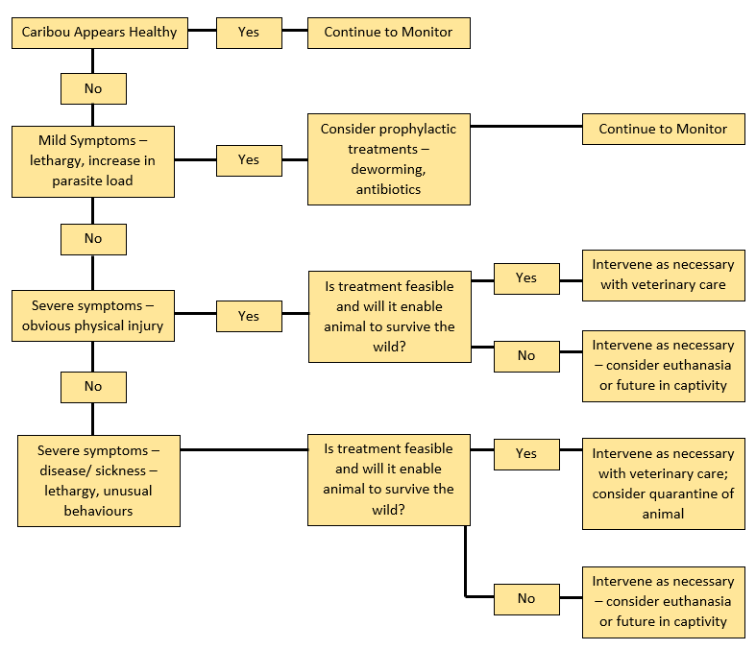

2.8 Intervention, Euthanasia, Necropsy, and Sampling
If an animal health condition is reported, a collaborative discussion between biologists, shepherds and veterinarians will occur and veterinary intervention will occur as soon as possible. Video recording and photos are valuable tools for communicating potential issues to veterinarians and should be obtained as soon as possible upon discovery of any concerns. Sedation, immobilization and/ or euthanasia will be carried out as required after discussion by veterinary staff. The project goal is zero mortality; however, any morbidity or death will be thoroughly assessed, investigated and diagnosed; mitigation to occur as soon as possible. Any mortalities, natural or from euthanasia, will be documented in the BC Caribou Research Program – Mortality Site Investigation Form and a necropsy by a veterinarian according to a standard protocol as soon as possible. Carcasses may be transferred to a freezer in Revelstoke for storage if a necropsy is not possible on site. Photograph and video the mortality site prior to disturbing the area. Supplies to be available in case of emergency:
- Extra-large, screw together padded dog kennel for calf transport
- Coolers and frozen water bottles for transporting samples
- Formalin, whirl packs, garbage bags, sharp knives (or scalpes) and markers
- Envelopes for DNA samples
- Veterinarian will provide other materials and tools for sedation, immobilization, treatment and necropsy

3. Calving

3.1 Cow Caribou Behaviour
The calving period encompasses roughly the 2 weeks leading up to calving, delivery of a calf (parturition), and a week after calving; there are specific considerations during this period that differ from other times. Caribou cows should develop larger udders during the last two weeks of gestation. Closer to parturition they may exhibit pacing, separation from other cows, less appetite or more secretive behaviour. Visibility in the enclosure makes observation of calving very difficult, and it is unlikely that normal delivery of calves will be observed.
Parturition occurs in stages – the final delivery follows a series of strong uterine contractions. Calves are usually born feet first with the head tucked between the forelegs. The cow may be standing or lying down. The birth starts with the passing of the amniotic sac and usually proceeds quickly, taking less than 30 minutes before the calf is on the ground and being licked by the cow. The calf will be covered with fluid and membranes and the licking stimulates the calf to move and rise. The afterbirth should follow the calf within hours and is generally consumed as well. Occsasionally the placenta is not completely passed and membranes may be visible at the vulva opening.
The healthy newborn calf will try to rise within 10 to 20 minutes and will nurse almost immediately. The first milk, known as colostrum, has very high protein levels due to the excretion of antibodies with the milk. It is essential for the calf to consume colostrum in the first few hours of life for protection from infectious diseases; this is called passive transfer of immunity.
Cows with newborn calves may remina secretive for several days post-calving, even if the calf is normal and healthy. The cow may ‘stash’ the calf in warm dry area and forage alone, returning to the calf repeatedly to allow it to nurse. Alternatively, cows may stay with their calves away from the rest of the herd.

3.2 Human Observations and Protocols During Calving
During the calving period, the number of observers may need to be increased to determine when calving occurs and to monitor the health and well-being of cows and calves. Visual check on each animal will be made at least 2 times per day. However, care must be taken to limit the disturbance of cows and calves. It is essential that cow-calf pairs not be disturbed during the first 24 hours of life as this is when the calf must consume colostrum and the maternal bond forms. Disturbance around the pen will be minimized, by following the established feeding regime and only entering the pen at other times if necessary to visually check on an animal that cannot be observed from outside the pen or to capture a calf for collaring. Visual observation of every animal from outside the pen should be attempted before entering the pen and then only if there is no risk of disturbing a new cow-calf pair in the process. All radio collar frequencies should be listened to at least 2 times per day to check for mortality signals and collar function. The primary goals of staff are to ensure a quiet secure calving environment, while still monitoring all animals to ensure that appropriate assistance is provided if necessary.

3.3 Veterinary Care During Calving
Most calvings are expected to be normal and not require intervention; however, a veterinarian will be available on site throughout the calving period. Visibility in the enclosure makes observation of calving very difficult, and it is unlikely that normal delivery of calves will be observed. If shepherds locate a calving cow, they should notify the veterinarian and all other staff on duty. Interactions with cows in labour should only occur if labour is not progressing or there is an obvious abnormality, according to Section 3.4: Decision Tree for Intervention During Calving.

3.4 Decision Tree for Intervention During Calving
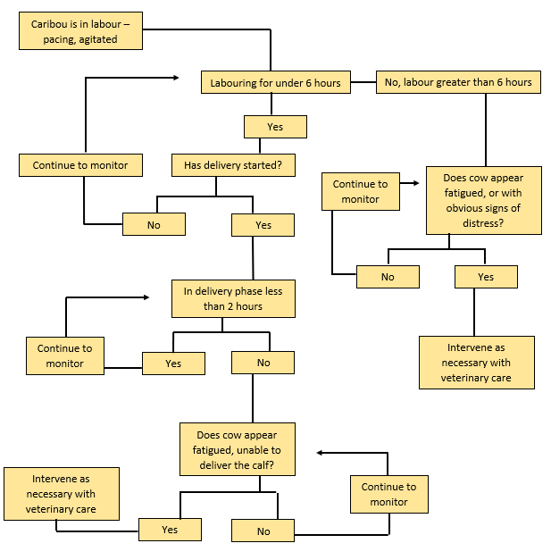

3.5 Calves
If collaring is required, calves will be handled only after 24 hours past birth (to reduce interference with cow-calf bonding and passive transfer of immunity), and within 48-72 hours (maximum), to record sex and weight, collect hair for genetic analyses, assess condition, and attach an ear tag and lightweight, expandable GPS radio-collar. These collars are fitted with a rot-off sections, allowing the collar to fall off within the next year.
Capture should not be attempted within 3 hours of darkness, near cows in active labour, near calves less than 24 hours old or when weather is excessively warm. Total handling time should be kept under 2.5 minutes, so procedures will be performed in order of priority (from most important – ear tag, sex, check umbilicus, collar, collect hair, weigh) with the least important only being performed if time permits. Two to 3 handlers will be involved, with one person keeping track of time, recording information in the ALCS Calf Capture form in SNAP and watching the cow. One handler will perform a rapid physical examination, looking for any sign of injury, illness, or abnormality. If any are found the details will be recorded and, where possible, a photo taken. If the time taken to capture the calf (chase time) exceeds 5 minutes, the chase should cease and be attempted again after 6 hours or the following day. If the calf is not caught within 5 minutes on the second attempt, no further attempts will be made. The chase time and time it takes the cow and calf to re-unite after capture is recorded on the capture form. The calf is observed from a distance after capture until it has reunited with the cow. It is often difficult to observe the cow-calf pairs without disturbing them, and care should be taken to avoid hindering the process of re-uniting.
If neonatal calves show the following signs, consultation with the veterinarian should occur immediately and intervention may be requirved. Whenever possible, obtain a video:
- Failure or difficulty to raise head or to stand, excessive shivering, weakness, incoordination
- Difficulty with or reduced number of nursing attempts
- Loose feces, changes in fecal colour or volume, straining to defecate or urinate
- Discharge from eyes, nose, mouth, anus, prepuce/ vulva
- Swollen navel
- Does not keep up with cow, behaviour appears abnormal or,
- Vocalization
- The calf is considered to be orphaned/ abandoned according to the following criteria: it has not stood to nurse within 2 hours and the cow leaves the calf or if the cow dies at birth. Abandoned/ orphaned calves will be assessed by the veterinarian and if the criteria are met, removed from the enclosure, treated as required for support, fed with calf milk replacement by bottle or stomach tube or rehydrated with intravenous fluids, and transported to a captive facility for care, (i.e. Calgary Zoo) as per the Emergency Hand-Rearing of Orphaned Captive Caribou Calves protocol (Appendix 9).

3.6 Cows
Cows will be observed closely (with binoculars or spotting scope) at least twice daily in the week following calving since this is when health issues associated with calving are most likely to become apparent. Abnormalities to look for and report include membranes or discharge from the vulva, a swollen, reddened udder, weakness or lethargy, or any other non-specific signs of illness. Fetal membranes are usually delivered within two hours of birth and consumed or partially consumed by the cow. If delivery of the membranes does not occur within approximately 6 hours of birth of the calf, the membranes are considered ‘retained’ which should be reported to the veterinarian since intervention may be required.

The cow’s udder is best viewed from behind. It is not particularly large when compared to domestic animals and it is abnormal if it appears very full or the cow refuses to let the calf nurse. Frequent checks and recording of observations informs early detection of health concerns and increases the chance of successful treatment. Health concerns of any kind, even subtle changes in behaviour or body condition, should be reported immediately to the veterinarian ot the veterinary team. Whenever possible, a photo or video should be taken.

If post-parturient cows show the following signs, consultation with the veterinary team should occur since intervention may be required:
- Straining after calf delivery
- Membranes or discharge from the vulva
- Distended, reddened or painful udder or not allowing the calf to nurse
- Cow is depressed and not moving normally
- Not observed eating, including browsing, for several days
- Rapid loss of body condition
- Separated from the herd, increased and decreased activity, or not moving away from human presence
- Diarrhoea or fecal staining
- Coughing or rapid breathing
- Vocalization
- Other abnormal behaviours or postures

Release From the Pen

4.1 Timing
Caribou cows and calves will be released in late July – August, when the youngest calf is a minimum of 3 weeks old or when conditions in the pen are considered extreme (i.e. excessive heat). In the Little Smoky project, the youngest calf was 19 days old on release (Smith and Pittaway 2011), while in Chisana the caribou were released mid-June, when youngest calf was 10 days old (CCRT 2010). In 2014, the oldest RCRW calf was 8 weeks old while the youngest was just under 2 weeks old at release. In that year, 8 of 9 calves were born by mid-June but the 9th calf was not born until July 8. In 2015, cows and calves were released on June 13th. In 2016 they were released on July 17th and in 2017 on July 16 & 17. In 2018 all animals were released by mid-June due to unusually high temperatures (25 – 30C) with the youngest calf only 8 days old.

4.2 Predators
Prior to release, human patrols should be increased for several days, with activity and noise focused away from the pen site. Patrollers will look for predators, scat, and foraging signs such as diggings in the area.
Cameras will be checked more frequently prior to release.
Discovery of predators in the area warrants the use aversion techniques (use of hounds), again, away from the site and delaying release by 48 hours. If predators are detected during the 48-hour delay period, the 48-hour delay restarts.

4.3 Release Technique
Four to five days before release the feed troughs are moved closer to the release gate along the north eastern flank to attract caribou to the area. Pelleted feed is gradually reduced during the period and small amount of lichen are provided. Caribou are to be release as early in the morning as possible. The release gate or fence section is opened along the north eastern flank of the pen. Typically caribou will leave the pen on their own accord within several hours of the gate being opened. Troughs should be moved outside of the pen and lichen added to entice them out. Caribou should not be forced or pushed out of the pen. Ideally the caribou will leave together, as a herd.

Human presence at the release site should be limited to 1-2 people. They are to carefully record all animals that leave or re-enter the pen.

Once all caribou have left the area, the pen is thoroughly swept on foot (and with the telemetry receiver) to ensure no caribou are left in the pen and the gate is closed. Feed troughs are brought into the pen.

In the case that cows and calves are separated at release (and a calf remains in the pen), inform the veterinarian and leave the pen open during daylight hours. Cows may return for their calves > 24 hours after release.

Monitoring After Release
The satellite GPS collars will provide daily emails on cow location and mortality status. Cow collars are also trnasmit through VHF. The calf collars are expandable VHF GPS VERTEX mini collars (VECTRONIC Aerospace).

Aerial surveys will be performed each March in conjunction with the provincial census. Calf survival will be calculated using the binomial estimator (Murray 2006), which is the number of marked calves observed during census divided by the number born the previous June in the pen. This metric is also tracked throughout the year (i.e. prior to the March survey), using the collars or flights as necessary. These survival rates are compared to estimated wild calf survival rates, based on recruitment data from the system from 1992 – 2013 (Wittmer et al. 2005b).

Near real-time tracking from the satellite collars provides movements of penned animals to traditional summer and fall habitats in the area (sensu Apps et al. 2001). All mortality signals are investigated as soon as possible to determine cause of death. In the event of a mortality, at least 2 researchers will access the site as soon as possible and will use the standard mortality investigation protocols provided by the B.C. Caribou Recovery Program and Wildlife Health Program. The protocol provides detailed forms outlining procedures, sampling methods, required equipment and standards for site investigation.

At a minimim those investigating mortalities should take photographs/ video, make extensive notes, observe caribou and predator tracks, scat, hair and tooth marks, and look for evidence of other mortality causes (avalanche, falls, vehicle collisions, etc.) and assess potential pre-disposing factors (broken bones, worn teeth, poor body condition, lack of marrow fat, etc.). For cows, the area should also be searched for the calf collar and remains.

Predators
One of the project’s goals is to prevent predation (i.e. have no predators enter the pen with no lethal removal required). Predators that occur in the area are wolves, grizzly bear, black bear, cougar, lynx, wolverine, coyotes and eagles. Protecting the caribou includes preventing the approach of predators through human presence, early detection of animals, and mitigation of persistent animals. Lethal removal of persistent predators may be requried as a last resort, but primary mitigration measures include a strong electric fence, physical barrier, consistent survelliance, aversive conditioning, and detection using motion-activated cameras at the fence and surrounding roads. Wide are sweeps will be conducted to ensure that there are no predator attractants in the area prior to caribou introductoin and during the penning period.

Most of the above predator species have been recorded by remotely triggered cameras or tracks within a few hundred metres of the pen.
The pen was constructed to provide a visual and physical barrier and includes a set back electric fencing to provide further deterrence minimizing the risk of predators entering the pen. Should predators be detected near or at the pen, intervention will follow protocols as outlined in Section 6.1: Decision tree for response to predators.

Specific details regarding protocols associated with predators include:
- Staff will perform pen perimeter patrols and road walks, several hundred meters up each access road at least 1-2 times per day, except if there are concerns regarding potential caribou disturbance (i.e. calving)
- Shepherd will be encouraged to hike a larger radius around the enclosure to increase the zone of human activity
- Remote cameras will be placed on access roads to monitor wildlife in the area. Cameras will be checked every two days. Cameras are strategically placed at the pen entrance near the caribou blind shack, around the pen perimeter and in both directions on the Kuskanax Forest Service road.
- If a predator approaches, human activity and noise will be increased in the vicinity of the predator
- Shepherd’s actions will follow the predator decision tree (Appendix 11). All shepherds will have training with firearms and deterrent techniques and have experience using their professional judgement to responsibly manage threats from predators. In general, the level of action against a predator will increase if the predator shows no sign of being deterred. Deterrent actions will progress from human noise and non-lethal methods such as bear bangers, rubber bullets, to lethal methods if necessary (i.e. predator attempts to get into the pen or is overly aggressive towards shepherds), and
- All observations of predators, all enclosures, and any actions taken, will be recorded in the Caribou Daily Log in SNAP. Escalating concerns about predators that require active deterrence measures will be reported immediately to the board operations committee and the Conservation Officer Service.

6.1 Decision Tree for Response to Predators
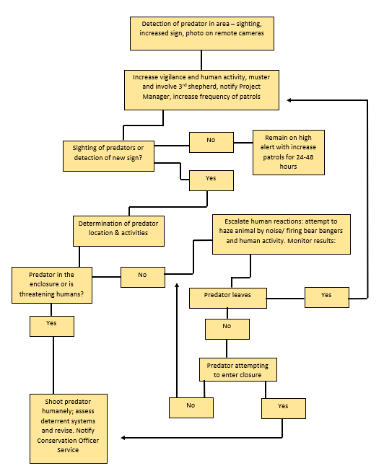

Forest Fire
The South East Fire Centre, along with fire managers, have been provided with an exact location of the pen, and it is established that the surrounding area is a top priority for fire suppression.
In the unlikely event of a fire near the enclosure, pen staff will:
            - Report the fire by phone by calling 1 800 663-5555 as soon as possible and provide the following information regarding the fire:
                - Location (inform them you are calling from the Central Selkirk ALCS caribou pen)
                - Size of fire
                - Rate of spread
                - Fuel type that burning (grass, bushes, trees, etc.)
                - Smoke/ flames (colour, visible or not)
                - Threat (its imperative that they’re informed of the level of risk to the pen)
                - Action (any current actions being taken to fight the fire)
            - Take appropriate action to release caribou and ensure human safety, if the fire threatens the life of caribou or staff.

Enclosure Details and Maintenance
The Central Selkirk pen was constructed in Kuskanax Creek drainage in old hemlock and cedar stands, within natural Central Selkirk caribou habitat, about 10 km northeast of the Village of Nakusp at 875 m elevation. The size of the pen is 6.6 ha, and has a perimeter of 1.2 km. The pen is comprised of non-woven ARMTEC 300 geotextile, measuring 4.57 m high suspended from a 5/16” diameter galvanized wire rope supported approximately every 5-10m with existing trees. The effective height of the fence is approximately 4 m within 0.5m serving as a ground level skirt laid toward the outside and the remaining draped over the 5/16” diameter wire rope and sewn to itself with UV resistant cable ties spaced approximately 1 m apart. One main blind and three tree stands are located around the pen to observe the caribou. The west ridge has sightlines cut out to look into the pen.

8.1 Electric Fence
A 2.4.m high electric fence surrounds the entire pen. It's supported by wooden post attached to the existing trees that old up the geotextile walls or wooden post that are dug into the ground. The fence is powered by a 110 V AC Kencove EKD16 energizer with a 10,000 V output capability. The system uses high tensile braided steel wire, rather than the more common braided poly-wire, as it provides a physical barrier and requires less maintenance. The fence has a total of six hot wires interspersed by four ground wires. The electric fence is controlled by the energizer attached to the back of the shepherd’s chalet at the Nakusp Hot Springs and by three switches at the southeast corner of the fence directly above the Hot Springs. The three switches allow various levels or ‘banks’ of hot wires to be electrified as snow gradually melts and exposes them. Switch one controls the top four hotwires with bottom hotwires having their own switch. In addition, the Kencove can be control over WiFi and will be loaded onto the pens iPad.

Since the snow melts unevenly within and around the pen individual banks of electric fence wires cannot be turned on until the entire length of every hot wire within each bank is completely free of snow. This can create a vulnerable situation along the fence if all of the wires are exposed under the trees but are still under snow elsewhere. In this case, a spool of braided wire could be used to add a lower temporary wire (secured to a higher electrified hot wire) if the snow has melted significantly below the lowest electrified hot wire or the rest of the fence will have to shoveled out free of snow.

Staff must check the geotextile pen wall and electric fence at least once daily to ensure:

        - There is adequate voltage tested with the Parmak digital volt meter. Acceptable voltages range from as high as 8000 V when only the top bank (four hot wires) is activated to as low as 5000 V when all three banks are activated. Voltages less than indicated suggest short circuiting likely due to vegetation contact or broken insulators,
        - Vegetation is not contacting any of the electrified hot wires. This grounds the system and draws power which can result in power failure if left unchecked. Geotextile approximately 1 m wide is located on the ground under the lowest wire to reduce vegetation growth but attention is still required along its edge,
        - Insulators on hot wires are in good condition. Check for any damage including hairline cracks. Turn off the main supply switch and replace all insulators that are broken or bent. Inspect cable guides for the ground wires and replace any that are broken or missing,
        - There are no loose electric fence wires. Loose wires need to be tightened by turning the nearest tensioning wheels or using the Gripple tension tool. Fence wires need to be tight location of tighteners are on the master map in the main blind,
        - There are no cracks in fence support posts or excessive bends. Report any deficiencies,
        - Geotextile is not coming into contact with the electric fence. Repair or tighten geotextile as needed,
        - There are no sags or separations in main support cable. Re-tension any separations with the come along and cable grips, adding a section of cable if necessary. Use only Crosby brand cable clamps,
        - The fence wall has no tears or rips. Sew and cover all rips or areas showing signs or wear using geotextile and cable ties,
        - There are no broken cable ties. Replace all ties that are broken or missing.

8.2 Water Supply
Water supply is gravity fed and comes from Raven Creek, suppling water to two individual stations. The two stations each have two water troughs made from 20 cm diameter by 7 m long PVC potable water pipe with 1/3 of the circumference removed and inlet and outlet fixtures added. The first station (‘NE Station’) is located at the Northeast corner and has two troughs in parallel. The second station (‘East Station’) is located along the east flank in view east of the main blind, it has two troughs in series. Valves control the inlet water flow at each station while outlet water is drained outside of the pen to prevent pooling. Water depth in the troughs is controlled by standpipes at the outlet ends. The standpipes ensure enough water is available. To assist with removal of sediment and debris the standpipes can be temporarily removed.
Staff must check the watering system at least once daily to ensure:
  - There is water flowing through the trough,
  - All water supply and trough drain line connections are intact and are not leaking,
  - The troughs are draining freely,
  - The troughs are clean of sediments and debris,
  - Intake will be checked once a week and more frequent during high flows and storm events.

8.3 Main Blind Electricity
The main electricity source for the pen main blind will be provided by two 6 V batteries, regulated by a 1000 V power inverter. Should the batteries loose power, a generator will be kept in storage at the blind to recharge the batteries. For optimal power levels, the operator should look for 12 V on the power inverter display after turning it on.
Refer to Appendix 10 for operation and maintenance of the power system.
Alternatively, solar power will supplement the charge in the batteries, and the system has potential to add additional 6 V batteries if the blind’s operations are using a significant amount of power each day.
A voltage reader can be installed in the main blind to monitor the voltage of the 12 V system.
  - 8.5 Wifi and Communication for Main Blind
Wifi signal to be received off of satellite, and fed through router for operation of blind desktop computer and pen monitoring Buck Eye cameras.

References
Adams, L.G., F.J. Singer, and B.W. Dale. 1995. Caribou calf mortality in Denali National Park. J. Wildl. Manage. 59(3): 584-594.
American Veterinary Medicine Association. 2013. AVMA guidelines for the euthanasia of animals: 2013 edition. See document: https://www.purdue.edu/research/regulatory-affairs/animal-research/docs/2013_AVMA_Guidelines.pdf
Apps, C.D., B.N. McLellan, T.A. Kinlet, and J.P. Flaa. 2001. Scale-dependent habitat selection by mountain caribou, Columbia Mountains, British Columbia. Journal of Wildlife Management 65: 65-77.
Chisana Caribou Recovery Team. 2010. Recovery of the Chisana Caribou Herd in the Alaska/ Yukon Borderlands: Captive-Rearing Trials. Yukon Fish and Wildlife Branch Report TR-10-02.
FLNRO Science team report, July 2013. An assessment of predation management actions to recover mountain caribou in British Columbia. Prepared by BC Ministry of FLNRO Fish and Wildlife Recovery Implementation July 23, 2013.
Gaillard, J.M., M. Festa-Bianchet, and N.G. Toccoz. 1998. Population dynamics of larger herbivores: variable recruitment with constant adult survival. Trends in Ecology & Evolution 13: 58-63.
Gustine, D., K.L. Parker, R. J. Lay, M. P. Gillingham, and D. C. Heard. 2006. Calf survival of woodland caribou in a multi-predator ecosystem. Wildlife Monographs 165: 1-32.
Kinley, T. A., 2010. Augmentation plan for the Purcells-South Mountain Caribou population. Prepared for BC Ministry of Environment, Victoria, BC.
Lance, N. J., S. W. Breck, C. Simec, P. Callahan, and J. A. Shivik. 2010. Biological, technical, and social aspects of applying electrified fladry for livestock protection from wolves (Canis lupus). Wildlife Research 37: 708-714.
McLellan, B. N. 2011. Implications of a high-energy and low-protein diet on the body composition, fitness, and competitive abilities of black (Ursus americanus) and grizzly (Ursus arctos) bears. Canadian Journal of Zoology 89: 546-558.
McLellan, M. L., R. Serrouya, B. N. McLellan, K. Furk, D. C. Heard, H. U. Wittmer. 2012. Implication of body condition on the unsustainable predation rates of endangered mountain caribou. Oecologia 169(3): 853-860.
Murray, D., E. W. Cox, W. B. Ballard, H. A. Whitlaw, M. S. Lenarz, T. W. Custer, T. Barnett, T. K. Fuller. 2006. Pathogens, Nutritional Deficiency, and Climate Influences on a Declining Moose Population. Wildlife Monographs. 166: 1-30.
Musiani, M and E. Visalberghi. 2001. Effectiveness of fladry on wolves in captivity. Wildlife Society Bulletin 29(1): 91-98.
Musiani, M., C. Mamo, L. Boitani, C. Callaghan, C. G. Cormack, L. Mattei, E. Visalberghi, S. Breck, and G. Volpi. 2003. Wolf Depredation Trends and the Use of Fladry Barriers to Protect Livestock in Western North America. USDA National Wildlife Research Center – Staff Publications. Paper 620. https://digitalcommons.unl.edu/icwdm_usdanwrc/620/
Pearce, Cindy. 2005. Chisana Caribou Cow/ Calf Captive Rearing Project – Key Information. April, 2005. Prepared for the Revelstoke Caribou Recovery Group.
Rohner, C. 1999. Caribou monitoring manual 1999-2000. Methods and protocol. University of Alberta, Dept of Renewable Resources, and Alberta Environment, Natural Resources Service, Edmonton, AB. 16pp.
Seip, D. R. 2008. Mountain caribou interactions with wolves and moose in central British Columbia. Alces 44: 1-5.
Serrouya, R. 2013. An adaptive approach to endangered species recovery based on a management experiment: reducing moose to reduce apparent competition with woodland caribou. University of Alberta, Edmonton.
Sifton, E. 2001. Disease risk assessment for an experimental captive breeding program of Mountain Caribou in British Columbia. Prepared for BC Ministry of Environment, Lands, and Parks.
Smith, K. G. and L. Pittaway. 2011. Little Smoky Woodland Caribou Calf Survival Enhancement Project. The 12th North American Caribou Workshop, Happy Valley/ Goose Bay, Labrador, Canada 4-6 November, 2008. Rangifer, Special Issue 19: 97-102.
Wittmer, H. U., A. R. E. Sinclair, and B. N. McLellan. 2005a. The role of predation in the decline and extirpation of woodland caribou. Oecologia 144: 257-267.
Wittmer, H. U., B. N. McLellan, D. R. Seip, J. A. Young, T. A. Kinley, G. S. Watts, and D. Hamilton. 2005b. Population dynamics of the endangered mountain ecotype of woodland caribou (Rangifer tarandus caribou) in British Columbia, Canada. Canadian Journal of Zoology 83: 407-418.
Wittmer, H. U., R. N. M. Ahrens, and B. N. McLellan. 2010. Viability of mountain caribou in British Columbia, Canada: Effects of habitat change and population density. Biological Conservation 143: 86-93.
Wittmer, H. U., B. N. McLellan, R. Serrouya, and C. Apps. 2007. Changes in landscape composition influence the decline of a threatened woodland caribou population. J. Animal Ecol. 76(3): 568-579.

Appendices

Appendix 1 – Crew briefing document (team manual)
Appendix 2 – Capture safe work procedure
Appendix 3 – Maternity Penning Caribou Drug Protocol 2017
Appendix 4 – BC Caribou Maternity Penning Data Form – 2018 – V1.0
Appendix 5 – ALCS Central Selkirk COVID-19 Protocols
Appendix 6 – Lichen Collection Handling Handbook (Use ALCS guidelines from website?)
Appendix 7 – Calgary Zoo Winter Herbivore Pellets – Formulae code M800710
Appendix 9 – Individual Daily Observation Record
Appendix 10 – Caribou Body Condition Score Chart
Appendix 11 – Decision Tree for Veterinary Intervention / Assistance
Appendix 12 – Calf Capture Form
Appendix 13 – Emergency Hand Rearing of Orphaned Captive Caribou Calves

